1 рівень

1. The test was on a PC

Yandex (v.25.8.0.1908)

| № | Bug description | Steps | Expected results | Actual results |
| --- | --- | --- | --- | --- |
| 1 | In the field “make an appointment”, when sending data for an appointment, only the phone number is required to add | 1. Click “Make an appointment”  2. Enter data in the Name and Phone fields  3. Click “Submit” | After clicking “Submit”, both fields are red (if no data entered) | After clicking “Submit” without any data, only the phone number is shown as required, but when you enter the phone number and click “Submit” only then field “Name” shown as required. (Note №1) |
| 2 | When entering a field of a doctor in the “search” field, it doesn't provide the necessary hint | 1. Click “Search”  2. Enter the necessary doctor | After entering a part of a doctor`s field in the search, it should give you a hint of the required doctor | After entering a part of a doctor`s field in the search, the search doesn`t give an appropriate doctor (Note №2) |
| 3 | Problem with the interface freezing when entering information in “search” field | 1. Click “Search”  2. Enter the necessary doctor | All information entered into the search field entered without freezing | After entering 2 letters into the search field entering other letters is provided with the interface freezing |
| 4 | After changing the language to Russian or English, the main ad remains in Ukrainian | 1. Click “Укр”  2. Click “Рус” or “Eng” | All information on the page changes into another chosen language in the language field | After changing the language to Russian or English, the main ad remains in Ukrainian. (Note №3) |
| 5 | The ad on the main page does not contain “left” and “right” arrows | On the main page | The ad on the main page should contain “left” and “right” arrows for easier switching of ads | The ad on the main page does not contain “left” and “right” arrows. Instead you should click and pull the ad. (Note №4) |

Note №1

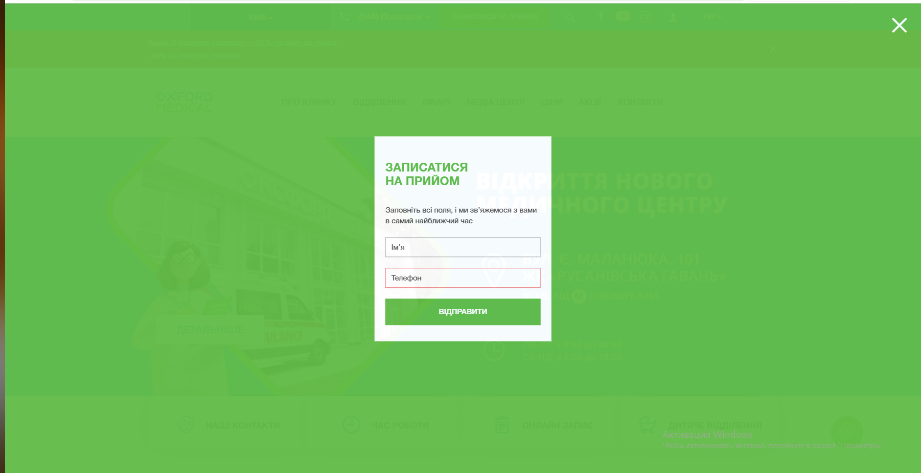

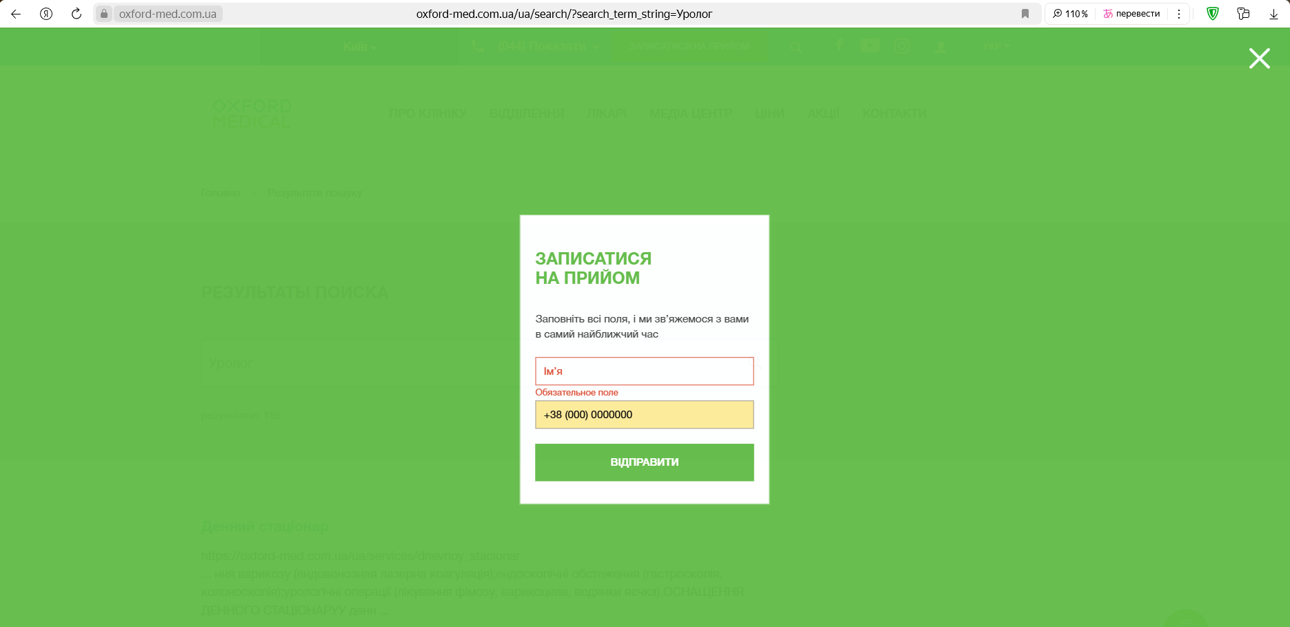

Note №2

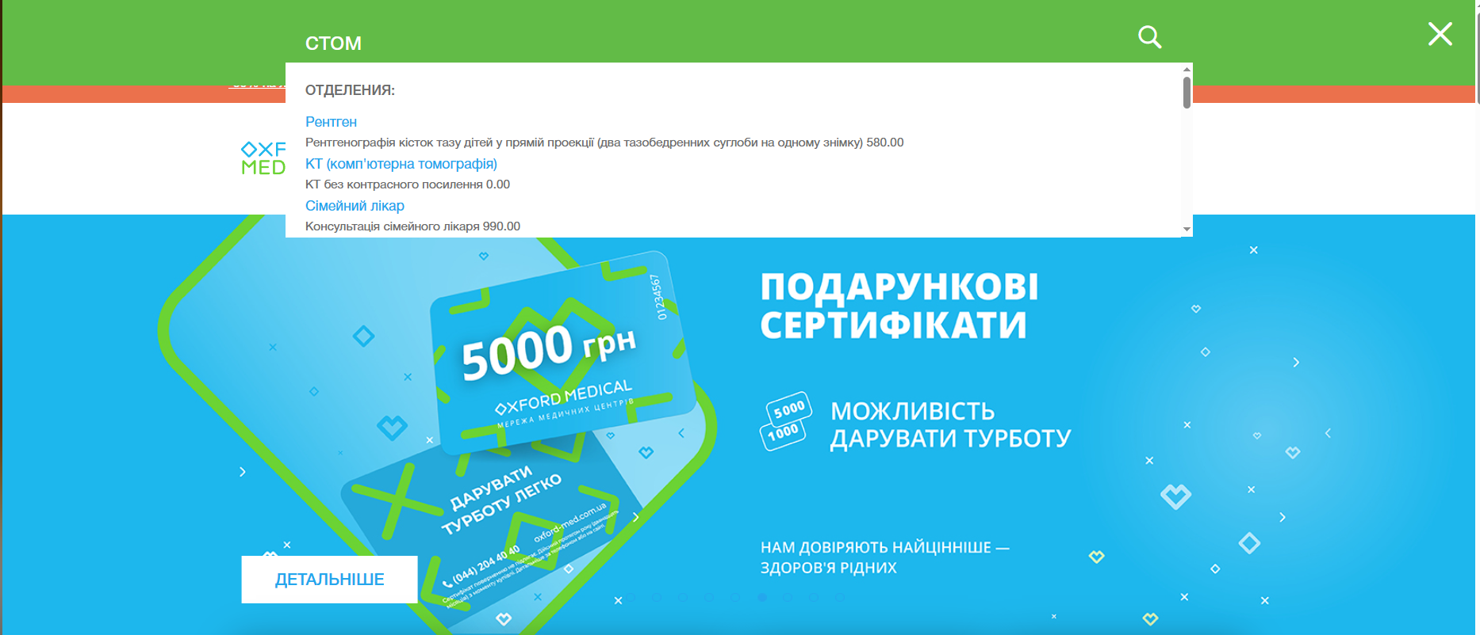

Note №3

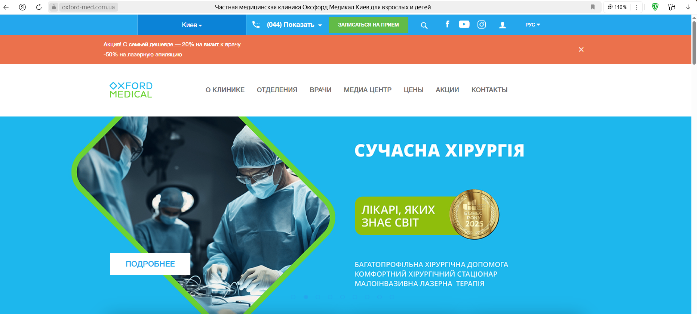

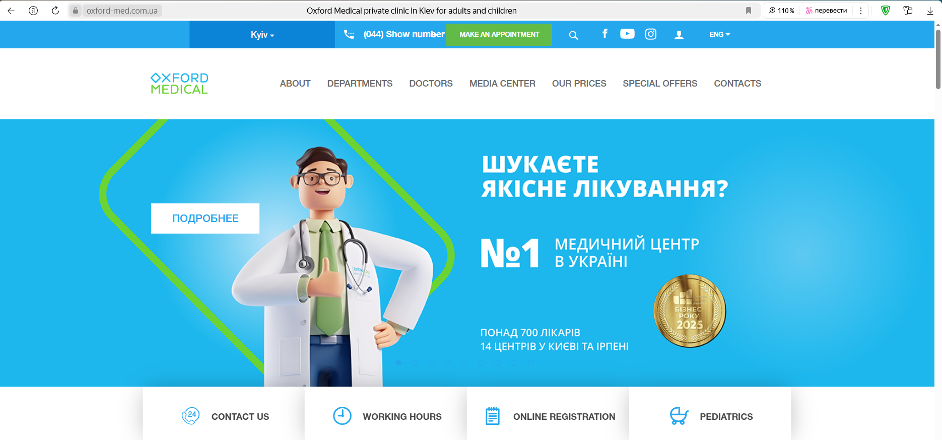

Note №4



2 рівень

1. The test was on a PC:

Edge (v.139.0.3405.111)

Opera (v.120.0.5543.161)

Yandex (v.25.8.0.1908)

All 5 bugs found in Yandex Browser are also present in other browsers.

3 рівень

1.

**Номер телефону:**

шрифт: HelveticaNeue-Bold, sans-serif

розмір: 16px

колір: #fff

колір бекграунду: #24a7ed

**Ім’я асистента**

шрифт: Open Sans, sans-serif

розмір: 16px

колір: #255 rgb (255, 255, 255)

колір бекграунду: #1db7ed

**Кнопка “інші міста”**

шрифт: HelveticaNeue, sans-serif

розмір: 14px

колір: #24a7ed

колір бекграунду: #ffffff

**Placeholder “ім’я” у формі “ЗАПИСАТИСЯ НА ПРИЙОМ”**

шрифт: HelveticaNeue, sans-serif

розмір: 14px

колір: #535353

колір бекграунду: #ffffff